 

**CRIMINAL DISCLOSURE DECLARATION**

**NAME : Jayashree Ragavan ADDRESS : No 10 Bharathidasan Street, Ma.po.si salai, Behind SBI, Tiruvallur -602001**

Have you ever been accused, charged and /or convicted for any criminal offence by a court of law in India or in a foreign Country?

~~YES~~ NO

SIGNATURE: 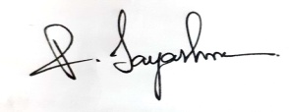

PLACE: Tiruvallur DATE: 09/05/2022

Copyright © 2014. All Rights Reserved. l Tech Mahindra Confidential. Version 2.3